

Concept of Operation Example
PAO – PSO Part 91 BVLOS waiver request

Purpose: The purpose of this document is to assist agencies with providing the brief and complete description of a Beyond Visual Line of Sight operation using other than Visual Observers required by the associated Public Safety Organization – Public Aircraft Operations – 91 BVLOS Waiver Checklist. This document is not a policy statement and is not a prescriptive statement but rather is intended to help agencies understand FAA requirements and common ways to meet those requirements. It also helps the FAA efficiently evaluate your request.
Instructions: Any text notated with a [BRACKET] is intended to be replaced by the applicant. Any text in italics is intended to provide guidance on how to complete that section. Text in italics should therefore be deleted before submitting the documentation to the FAA.

Table of Contents
1 Assumptions 3
1.1 Flight Area / Jurisdiction 3
1.2 Small Unmanned Aircraft System 3
1.2.1 Aircraft 3
1.2.2 Ground Control Station 4
1.2.3 Connectivity 4
1.2.4 Parachute Recovery System (if applicable) 4
1.2.5 Docking Station (if applicable) 5
1.2.6 Remote ID 5
1.3 Flight Crew Qualifications and Training 5
1.3.1 Qualifications 5
1.3.2 Training 6
1.3.3 Currency 6
1.4 Use of Local ADS-B In 6
1.5 Operations below 200’ AGL or within 50’ of structures 7
2 Normal operations 9
2.1 Agency Standard Operating Procedures 9
2.2 Site Survey 9
2.3 Pre-Flight Actions 9
2.3.1 Start of Shift or Once Every 24 hours 9
2.3.2 Prior to flight 10
2.4 Mission Operations 11
2.5 Strategy to Remain a Safe Distance from Aircraft 11
2.6 Operations Over People 11
3 Abnormal and Emergency Operations 12
3.1 Emergency Response Plan 12
3.2 Loss of Link 13

Assumptions

Flight Area / Jurisdiction
Identify the planned area of operation, include a graphic of this area and description of the airspace within it below. It’s recommended that the agencies get familiar with their airspace during this process, including where public and private airports are, heliports are, and other features of the airspace they will be operating in.
Skydio has created an FAA airspace web app to help with airspace familiarization: https://skydio-inc.maps.arcgis.com/apps/instant/basic/index.html?appid=3d69cc20c1aa46c5b1359fbe16c11dc7

Operator will primarily operate in [CITY / COUNTY / STATE] but requests the ability to operate nationwide in Class G and E3/E4 airspace.
[INCLUDE A SCREENSHOT OF THE AREA USING UAS VISUALIZE IT OR THE URL ABOVE]
The flight area includes the following types of airspace:
- [LIST EACH AIRPORT AND TYPE OF CONTROLLED AIRSPACE]

Small Unmanned Aircraft System
Add the information for the drone make/model(s) you intend to operate. The Skydio X10 is included as an example in the sections below.

The system is comprised of the following elements:
Aircraft: | Skydio X10
Ground Control Station (GCS): | Skydio Remote Flight Deck or X10 Controller
Launch Method: | Skydio Dock or ground-launch

The Operator will adhere to OEM documented procedures, conditions, and limitations.

Aircraft
Provide a brief description of the sUA including size, weight, endurance, speeds, attachments, and anti-collision light capability. An example is provided below.

UAS Make/Model: | Skydio X10
Maximum flight time, range, and speed: | Max Endurance: 40 minutes (in optimal controlled conditions)  Max Speed: 36 mph (with obstacle avoidance on)  Range: Dependent on factors such as airspace, environment, LTE/cellular coverage, and battery endurance
UAS Size (dimensions and weight): | Weight: 5.49 lbs  Unfolded: 25.6” x 31.1“ x 5.7”
UAS attachments (if applicable): | Options include, but are not limited to, spotlight, speaker, Parachute Recovery System (pending), RTK GPS, NightSense

Ground Control Station
Provide a brief description of the ground control station interface, including at least one screenshot of the primary flight display. Include information about how the PIC knows the sUA’s altitude, attitude, position, direction of flight, battery status, and command and control status. Include information about how the PIC controls the sUA. Provide information about how the PIC can monitor the health of the sUA and any alerting capabilities.

Skydio X10 will be operated through Skydio Remote Flight Deck (web-based GCS) or Flight Deck on X10 Controller.
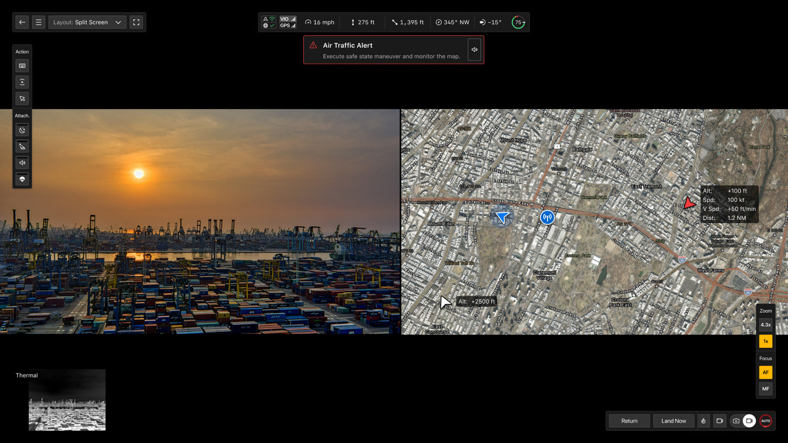
Figure 5 Remote Flight Deck
Both GCS options include:
- Real time telemetry including sUA altitude, position, direction of flight, battery status, C2 status, and more
- Controls to manipulate the sUA for manual and automated flight
- Payload controls to capture the necessary data
- Alerts, warnings, and contingency behaviors to make the Pilot in Command aware of issues with the sUA and ensure the issue can be resolved safely and efficiently.

Connectivity
Provide a brief description of the sUA’s command and control capabilities. Include each type (point to point link, cellular, satellite), the FCC ID for each, and the type of spectrum. An example is provided below. If the sUA has multiple connectivity options, provide the details for each.

Skydio Connect 5G (cellular)
- Make/model: Telit FN980
- FCC ID: RI7FN980
- Will not use Band 5
Skydio Connect SL (point-to-point link)
- Part 15E spectrum
- FCC ID: 2ATQRSMODBV3
Link between Skydio Cloud and Skydio Dock for X10:
The link between Skydio Cloud and Dock is expected to be a performance-based broadband link (wired or wireless) with average latency of 150ms and maximum of 500ms for teleoperation.

Parachute Recovery System (if applicable)
For operating over human beings in non-life saving situations with a drone over 0.88 lbs: a mechanism to prevent rotating parts (propellers) from causing lacerations to humans and a Parachute Recovery System (PRS) are required.
For operating over human beings in life saving situations, these items are optional.
Include details about these items if applicable, including:
- Compliance with any standards, including ASTM F3322-18 or newer for Parachute Recovery Systems
- Provide information showing how the small, unmanned aircraft (sUA), upon impact with a person, will not exceed a low probability of serious injury or casualty, does not have any exposed rotating parts that could lacerate human skin, and does not have any safety defect(s) that exceed a low probability of causing serious injury or casualty
- Provide information about the PRS including make, model, serial number, testing data for the parachute, and safe deployment altitude.

Docking Station (if applicable)
Provide a brief description of the docking station’s capabilities. For example, sUA charging method, connectivity capabilities, environmental controls, and PIC tools for preflight inspection such as cameras or weather station.

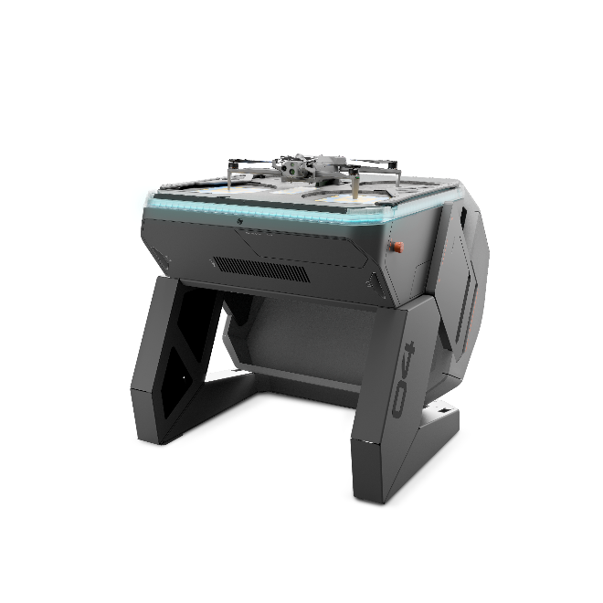
Skydio Dock for X10 is a network-connected enclosure and charging station which allows Skydio aircraft to be stationed in strategic locations and operated remotely to provide scheduled and on-demand flight operations. The Dock also includes features such as Dock Camera, a weather station, and an integration with a local ADS-B receiver.

Figure SEQ Figure \* ARABIC 6 Skydio Dock for X10

Remote ID
The X10 is Standard Remote ID compliant via WiFi beacon. Declaration of Compliance tracking numbers are RID000000749 and RID000000750.

Flight Crew Qualifications and Training
Provide a brief description of the qualifications and training for each flight crewmember. How many personnel are needed and what are their roles? What kind of training is required to operate under this waiver? An example is provided below.

The flight crew consists of a Pilot in Command (PIC). The PIC may optionally use a Visual Observer (VO) to scan airspace around the sUA for hazards.

Qualifications
PIC minimum qualifications include:
- Valid Remote Pilot Certificate,
- Completion of training described below
VO minimum qualifications include:
- Training on responsibilities for preflight, takeoff, and landing

Training
The Operator will complete training in accordance with their agency policy, as well as BVLOS-specific training for this ConOp as described below. The Responsible Person will track this training and verify it is completed before operations are conducted under an approved waiver.

Pilot in Command
Each PIC will be trained on how to conduct the proposed operations in this ConOp. Training includes:
- sUA limitations
- sUA programming
- sUA operational procedures
- Abnormal procedures
- Air traffic avoidance procedures
- sUA flight training which includes a demonstration of sUA ground and flight skills
Visual Observer
Completes training on the following items:
- Visual Observer responsibilities
- sUA preflight inspection
- Site Survey and selection of a suitable takeoff and landing location
- Phraseology
- Scanning techniques

Currency
PICs and VOs will follow the currency requirements outlined in the agency’s policy.

Use of Local ADS-B In
Describe how ADS-B is integrated into the system. Describe how the PIC is alerted to low flying aircraft in the sUA’s vicinity. Describe how the PIC uses ADS-B to avoid low flying traffic that may get within a safe distance of the sUA. Provide some screenshots or diagrams of how the ground control station displays ADS-B traffic and helps the PIC make collision avoidance decisions.

A local ADS-B receiver (owned and operated by the Operator) is integrated with the GCS to display real-time cooperative aircraft to the PIC. The receiver is either:
- On-board the X10, or
- In the Skydio Connect External Radio (connected via ethernet to X10 Dock)
The Map View declutters the display so that the PIC sees only the traffic that is in proximity to the flight area (within 6 NM laterally or 3,000’ vertically). Remote Flight Deck includes an audible and visual ADS-B alert that appears prominently on all the views and directs the Remote Pilot to check the Map View. This alert triggers when ADS-B traffic gets within 1.2 NM laterally AND 1,000’ vertically from the drone’s position. When a Pilot receives a traffic alert, he or she is trained to check the Map View, assess if the aircraft is expected to get within 500’ laterally and 100’ vertically of the sUA, and conduct a Safe State Maneuver if necessary.
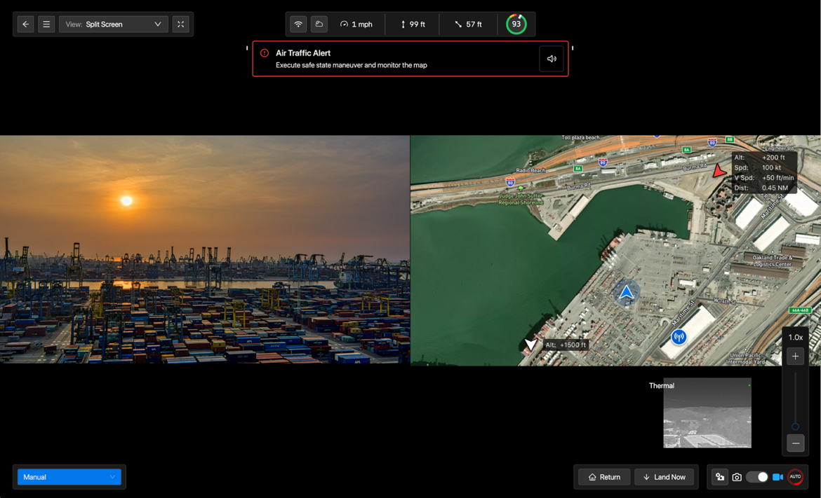
Figure 2 Skydio Remote Flight Deck with ADS-B Data

Operations below 200’ AGL or within 100’ of structures
This “low technology” waiver relies on shielding as the primary mitigation for collision avoidance. Shielding refers to the concept of operating at low altitudes where crewed aircraft do not typically operate, other than for cases such as takeoff and landing at airport/heliports. The FAA has determined that operating at or below 200’ AGL, or within 100’ of an object/structure is an effective mitigation for encounters with crewed aircraft.
This waiver will have two maximum altitudes:
- In uncontrolled airspace, 400’ AGL is considered a hard ceiling and must not be exceeded
- In controlled airspace, FAA UAS Facility Map altitudes will be considered a hard ceiling and must not be exceeded

The Operator will operate:
- At or below 200’ AGL or within 100’ of an object/structure
- In uncontrolled airspace or in controlled airspace up to the FAA UAS Facility Map altitude
  - In uncontrolled airspace, 400’ AGL is considered a hard ceiling and will not be exceeded
  - In controlled airspace, FAA UAS Facility Map altitudes will be considered a hard ceiling and will not be exceeded
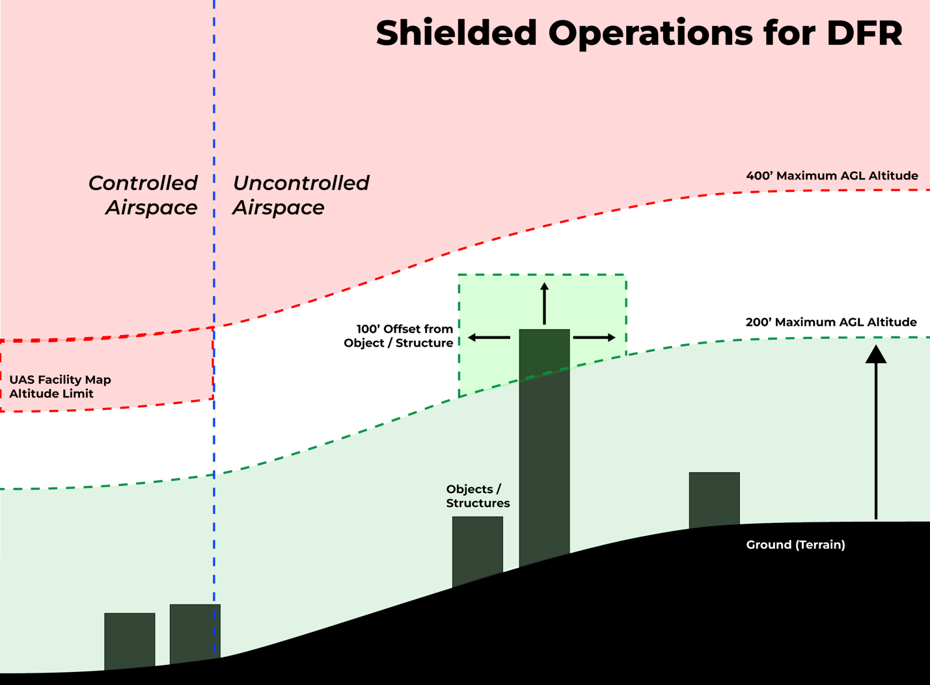

Normal operations

Agency Standard Operating Procedures
Operations will be conducted in accordance with the Operator’s Standard Operating Procedure (SOP). Operations will also adhere to any provisions of the issued COA.

Site Survey
For dock-based operations, the Operator will conduct a site survey prior to conducting operational DFR missions and night operations in an area. The following minimum items will be checked during the site survey:
- Areas or routes of low-level helicopter and airplane operations, such as helipads, grass airstrips, airports, military operations areas below 500 feet above ground level (AGL), tour operator flights, and farmland suitable for agricultural aircraft operations,
- Location(s) of expected pedestrian and/or vehicular traffic, and
- Power, networking, and physical installation requirements for Docks (if being installed)
- Obstacles and structures that could be a hazard to the flight operation or impact C2 performance
For tactical, hand-launched operations, the Operator will conduct a site survey when time allows to determine the presence of obstacles and structures that could be a hazard to the flight operation.

Pre-Flight Actions
Describe how the PIC conducts pre-flight and readiness activities to ensure the sUA is in a condition for safe operation and the PIC is familiar with all available information.
An example is provided below.

Start of Shift or Once Every 24 hours
The PIC will complete a thorough preflight familiarization, inspection, and flight briefings prior to beginning flight operations to become familiar with all available information.
Table 1 Full sUA preflight inspection completed once per shift / 24 hr period
Airspace check | Checks for TFRs using https://tfr.faa.gov/ or other source of FAA data
Weather check | The Remote Pilot will use aviation weather sources and nearby weather stations to check current and forecast weather conditions are appropriate for flight.  - Digital weather checks  - The Remote Pilot will get an Area Brief from www.1800wxbrief.com or equivalent source to view current and forecast conditions at and in the vicinity of the flight area  - An Area Brief includes standard weather products such as METARs, TAFs, area charts, significant weather forecasts, and NOTAMs.  - The Remote Pilot can also use the Graphical Forecasts for Aviation - Low Altitude Tool to view broad area weather conditions at low altitudes  - Check any other available sensors, such as weather information at the docking station (if used)
Flight review | Similar to a safety briefing, the Remote Pilot will review the upcoming mission:  - Planned flight profiles (lateral and vertical)  - Review of obstacles and structures in the flight area for night operations  - Verification that the Return Behavior is set to avoid highly congested urban and rural areas  - Review of the Emergency Response Plan and points of contact  - Review of COA provisions
Notifications | The PIC will issue notifications based on the flight operation as required:  - Coordinate with ATC as required  - The PIC will verify a NOTAM has been filed for the operational area
Aircraft condition and readiness check | The PIC will conduct a full aircraft condition check in accordance with agency policy and OEM recommendations.
ADS-B In check | The Remote Pilot will verify the ADS-B receiver is functional.

Prior to flight
Immediately before takeoff, the PIC will conduct an abbreviated pre-flight inspection:
Table 2 Abbreviated pre-flight before takeoff
Airspace check | Checks for TFRs or other airspace changes
Weather check | Verify weather conditions are still suitable for flight operations by using FAA weather products (METAR, TAF, FA) and other available weather sensors.
Flight review | Verify flight mission profile, obstacles in flight area, and Return Behavior.
Notifications | The PIC will issue notifications based on the flight operation as required:  - Coordinate with ATC as required
Aircraft condition and readiness check | - Verify sUA connectivity  - Verify sUA battery level suitable for mission  - Verifies sUA health by checking telemetry and alerts/warnings on GCS.
ADS-B In check | Verify ADS-B data is available
Check of area surrounding takeoff location | Check that the area around the takeoff location is clear.

Mission Operations
Describe the actions a PIC takes during flight to execute the mission and monitor sUA status. How does the PIC maneuver the sUA to execute the mission? Is maneuvering automated, manual, or a combination of both? How does the PIC know the location, altitude, and status of the sUA? How does the PIC observe the airspace or surrounding environment to ensure the sUA does not pose a danger to persons or property?

Strategy to Remain a Safe Distance from Aircraft
Describe how the PIC uses ADS-B data to make collision avoidance decisions. Does the GCS alert the PIC of low flying traffic? What is the criteria for the alert? What actions should a PIC take when low flying aircraft are present?

Operations Over People
Describe how the PIC makes a determination when it is appropriate to operate over human beings, or when and what strategies are used to minimize operations over human beings
An example is provided below.

PICs will only operate over non-participants and moving vehicles when it is necessary to safeguard human life. When necessary to safeguard human life, operations over human beings will be minimized to the extent possible.
In all other cases, the PIC will use a number of strategies to avoid operating over non-participants, such as:
- Real-time video from the sUA assists the PIC in avoiding operating over non-participants.
- The PIC will position the sUA over structures, areas of vegetation (trees), and areas where non-participants are not typically present (water) when possible
- The PIC will set contingency behaviors, especially the sUA Return Behavior, to minimize operations over highly congested areas when the sUA is executing the maneuver.

Abnormal and Emergency Operations

Emergency Response Plan
Describe the agency’s emergency response plan in the event of an accident or incident. An example is provided below.

Operator has developed, and trains flight crews on the Emergency Response Plan, and flight crews are expected to use the procedure outlined below when a drone incident occurs.
Steps of this procedure include:
- The Remote Pilot will notify the local Point of Contact that a drone emergency has occurred and provide:
  - Brief description of what occurred.
  - Known or last known location of the sUA.
- The local Point of Contact will attempt to locate the sUA
- The local Point of Contact will request immediate emergency response or medical assistance if necessary
- The local Point of Contact will ensure the site is safe
- The local Point of Contact will preserve the site, including aircraft data logs
- The Remote Pilot will communicate to the appropriate personnel
Incidents and accidents will be reported as required by COA provisions and NTSB requirements.

Loss of Link
Describe the sUA’s loss of link behavior and the actions the PIC takes during loss of link.

